# Managing EICs

## Getting Started

To call any of the below APIs, the first step is to retrieve a OAuth2 Bearer token from PIM360 via either 2-legged or 3-legged flow. (Link to Authentication tutorial) The token must then be included in all requests to PIM360 or CLS360 APIs

Make sure that the account that will be calling the APIs has the relevant capabilities by signing into PIM360, navigating to the EIC Explorer page and creating a new EIC by clicking on the “Create New EIC” button.

## Reading EIC details

A summary list of all EICs can be retrieved by calling the GET /eic/list API, this API requires no parameters. This will return an array of EIC details with the “rows” property of the response

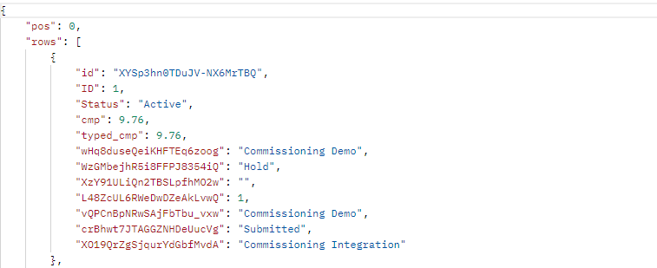

Each entry in the collection contains the handle of the EIC (id), the EIC Number (ID), its Status, Completeness and Typed Completeness. The rest of the object properties represent attributes on the EIC, where the key is the handle of an attribute, and the value is the value of that attribute.

To resolve the attribute name, call the CLS360 API /domains/{domHdl}/classes/{clsHdl} and pass in the attribute handle for the clsHdl parameter.

It is also possible to return a subset of EICs based on the value of the EIC attributes. This can be done by calling the POST /eic/query API and providing the attribute and value to filter on.

## Creating an EIC

To create an EIC, call the POST /eic/list specifying a list of attributes in key value pairs. The key must be the attribute handle, and the value is the value for the attribute. It is required that a class is specified when creating an EIC, the handle of the class should be used as the value. All data should be submitted in JSON format in the body of the request.

Figure 1Create EIC Request

On a successful response, the handle of the newly created EIC will be returned.

## Editing an EIC

The same API used for creating EICs can also be used for editing. To do this, provide the handle of the EIC to edit and the attrs array should contain the attribute(s) to update.

Figure 2 Edit EIC Request